SQL WORK –

* TO JOIN ALL THE TABLES

create table hotels as (

(select * from eighteen)

union

(select * from ninteen)

union

(select * from twenty));

**Note:** Here I assigned the name of all tables as their number of the year. Like 2018 as ‘eighteen’ and 2019 as ‘ninteen’.

* TO GET REVENUE(TOTAL NIGHT STAYS*ADR) AS PER YEARS AND HOTELS.

select

arrival_date_year, hotel,

round(sum((stays_in_week_nights+stays_in_weekend_nights)*adr),2) as revenue

from hotels

group by arrival_date_year,hotel;

For reference-

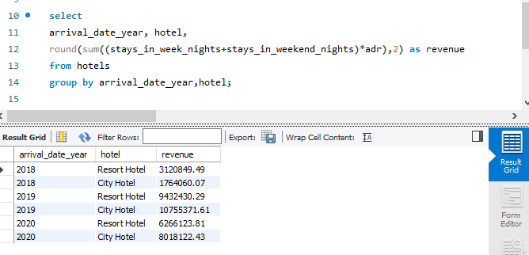

* TO JOIN LEFTOUT TABLES ON THE BASIS OF SIMILAR COLUMN

select * from hotels

left join project.market_segment

on hotels.market_segment=market_segment.market_segment

left join project.meal_cost

on meal_cost.meal=hotels.meal;